**Networking Essentials**

**Internship Project Report**

**Contents**

**Project Title page number**

* Project Overview 3
* Dataset extracted using Sniffer. 4-5
* Flowchart representation of network path taken by packets 6

**Final Problem Statement:** The main objective of this project is to create the visual representation of the packet flow from a desktop/laptop to other device on another network outside the campus/building.

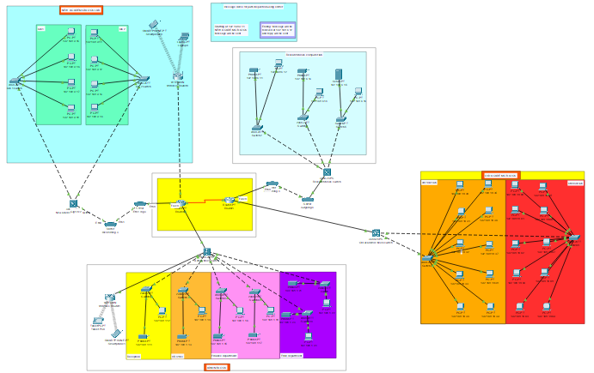

* This is the basic structure of the campus network representing how the connections are done.
* The pc with IP address 192.168.9.11 and the pc with IP address 192.168.6.12 from other local network connection to another router have been tested out for packet sending and receiving.
* Sniffers are being attached in the path of the network to extract the specific details needed for flowchart.
* After routing and getting the pc connected, the path taken by the data packets are shown in the flow chart.

**Data Extracted Using Sniffers:**

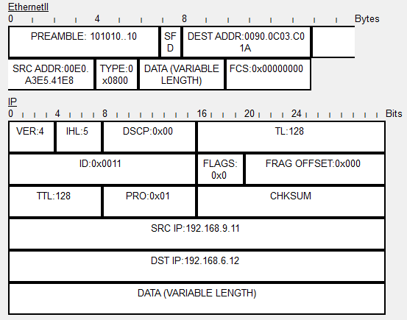

SRC ADDR:00E0.A3E5.41E8 : is the First PC mac address on which message was sent

DEST ADDR:0090.0C03.C01A : is the router 0 that received the message for forwarding

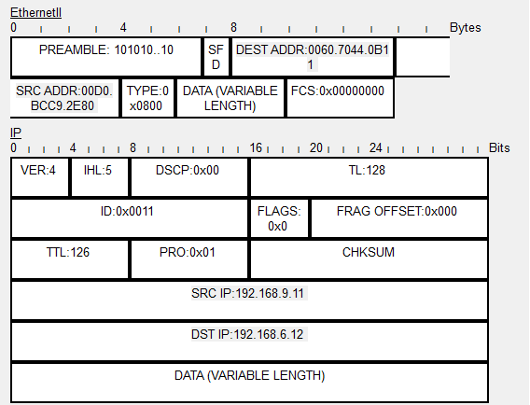

DEST ADDR:0060.7044.0B11 : mac address of PC which will receive the data from first pc

SRC ADDR:00D0.BCC9.2E80 : mac address of PC that sent the message

After receiving the message, the reply is sent through the same path, and we can observe that the destination and source are exchanged in the IP header. This helped us to trace out the path between the two PC.

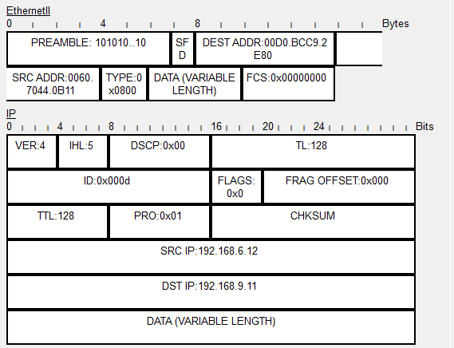

**Flowchart**:

( Done using lucid flowchart application)